Hiding Behind National Security: How US Politicians Have Used Tariffs to Gain Political Support though a New Data Set

Elle Diether

University of Texas at Austin

*February 6th, 2025*

**Introduction**

In a symbolic gesture, President Biden held up a small semiconductor chip before signing an executive order in the State Dining Room of the White House to establish a domestic supplier of semiconductor wafers (Jin and Nellis, 2021). Traditionally, economic theories like Ricardo-Viner suggest that individual trade preferences are shaped by stable economic factors, and therefore immovable. So, why would President Biden dedicate valuable time and resources on semiconductor conferences and executive orders to explain the importance of tariffs if such measures are unlikely to alter the public’s trade preferences?

Another recent example comes from the presidential debate between former President Trump and Vice President Kamala, where Trump opened by highlighting tariffs, making it a key point in the debate (Hoffman, 2024). Before 2016, tariff and trade policy were rarely discussed publicly especially by Republicans who were generally free trade. However, since the 2016 election tariffs have been put in center stage, but not through the older arguments of saving American jobs (protectionism) but in terms of protecting national security (securitization). The literature currently lacks an explanation for the sudden rise in talking about tariffs (especially in securitization terms), and why particular trade policies are promoted by politicians.

Most tariffs and trade policies are hidden behind closed doors and complex bureaucracy (Kono 2006). Given how easy it is to keep trade policies hidden, why have tariffs emerged as a prominent issue in recent elections? The average voter has limited time and capacity to understand the intricacies of trade, and studies have shown that economic theories of trade preferences are not intuitive (Keser et al., 2023; Mutz & Eunji Kim, 2017). This presents an opportunity for U.S. politicians to shape the information voters have about trade, shaping their preferences. This paper seeks to understand when US politicians use national security to gain support for themselves and their trade policies.

**Literature Review**

*Trade Preferences*

The foundation of trade policy and preferences has centered on interindustry differences. Countries specialize in goods that rely on factors (mostly capital and labor) that they have in abundance and import the goods that use factors that they are scarce in. There are two fundamental competing models of trade preferences based on the previous idea, Stolper-Samelson theorem, and the Ricardo-Viner model. The Stolper-Samuelson theorem assumes that there is capital and labor mobility, so wages and rents of capital are identical across industry. International trade pits countries with abundant factors’ industry whose incomes grow with trade against its scarce factors’ industry whose incomes decrease with trade. Contrary to this, the Ricardo-Viner model assumes that there is no capital and labor mobility so those in industries with a comparative advantage will prefer free trade and those in industries without a comparative advantage will oppose free trade. Based on these models the politics of trade are based on capital and labor mobility (Alt et al., 1996; Hiscox, 2002; Beaulieu, 2002;).

The problem with these foundational theories is that they don’t have a great track record of describing actual patterns of trade policy (Feenstra, 2015). The new trade theory (NTT) was developed to try to explain the pattern that industries both face export and import competition. NTT identifies that increasing returns of scale and consumers’ love variety creates a large intra industry (Krugman, 1980). NTT assumes firm level homogeneity, so the literature has expanded to incorporate firm heterogeneity in firm centered theories of international trade. Trade liberalization results in a reallocation of products and profits in industries so only the most productive firms can become multinational (Osgood 2016; Kim 2017). Therefore, large firms support trade liberalization and smaller firms do not. Whether or not these preferences translate into trade policy depends on collective action. Due to the difficulties and costs of getting preferences, preferences only translate into trade policy when the costs are high and there are big enough companies to pay for the policy, will preferences turn into policy (Maciel and Fischer 2020). According to collective action, multinationals should always win, resulting in mostly free trade policies. However, this doesn’t explain the current rise in tariffs and non trade barriers.

The final area of trade preferences is that of individual voters. Voters are both consumers (who prefer free trade because it decreases prices) and producers (whose preferences depend on their industry). Studies have focused on both voters as consumers and producers generally finding people care more about their role as producers in trade policy since that impacts their source of income (Betz and Pond 2019; Guisinger, 2009; Baker 2005). However, all these economic theories fall to explain the majority of people preferences, leading to the study of non-economic factors such as identity, partisanship, and gender which have impacted people’s trade preferences (Brutger, and Guisinger, 2021; Keser et al, 2023, Mutz and Eunji Kim 2017). Trade preferences are not solely determined by a person's industry and a country's comparative advantage. Several studies (Botelho et al 2009, List 2006) have found through lab experiments

that individuals often betray rationalist game theories expectations that are foundation to traditional economic theory. This allows trade preferences to be shaped by political elites.

*Elite Influence*

There are many theories for why people are influenced by their political position and statements. A prominent theory is that people use politicians and political parties as informational shortcuts, people time and mental capacity is limited so they use opinion of politician and parties they trust to form an opinion (Carmines and Kuklinski 1990; Lupia 2006; Sniderman and Stiglitz 2012). Another theoretical model emphasizes the importance of politicians and their associated political parties with individual identity. In order to maintain a strong partisan identity and prove their loyalty to the group, people adopt their politicians and political parties' policies and beliefs (Campbell et al. 1960; Green, Palmquist and Schickler 2002; Huddy, Mason and Aarøe 2015). Finally, studies have examined how politicians engage in agenda setting in public, using their superior resources and recognition to make certain policies and issues more dominant in the public discourse (Rogers and Dearing; Birkland 2017; Protess and McCombs 2016).

Elite influence and cues on public opinion on trade policies are limited mostly to particular large trade deals such as NAFTA and TPP (Dur and Mateo 2014; Scrubby 2022). Trump and his cues have been the subject of scholars in trying to understand how he gained support for anti free trade policies (Essig et al 2021; Bledon et al 2017; Keser et al). These studies are however limited, due to the long time consensus that public opinion on trade does not matter due complexities of trade agreement (Kono, 2008). This was a sufficient answer in the 90s and 2000s back when Republicans were supporters of free trade. However in today's political environment, both Democrats and Republicans are bringing up the topic of tariffs to gain support for their political party as a whole. The language that both parties are using as cues has changed in the last decade, shifting to be national security based arguments. Political elites are using their scarce platforms, time, and agenda setting power to talk about tariffs. This paper seeks to develop a theory on why and how political elites use trade policy and the justification of national security to aid their own popularity and goal.

*Securitization*

The United States is both a founding member and one of the most influential participants in the World Trade Organization (WTO). The WTO’s primary goal is to reduce trade barriers among its members, promoting the benefits of free trade. However, many countries, including powerful ones like the U.S., often turn to protectionism for various reasons. To address situations where large nations implement protectionist policies, the WTO has developed a list of exceptions, including the important security clause. This clause is intentionally broad, allowing states to implement protectionist measures in the name of national security. As long as the security clause is not overused it will remain exogenous and the WTO can remain binding. For the United States, maintaining the WTO is important because it allows the US to benefit from free trade, but ideally the US would have free trade with its partners but keep its own protectionists. However, if the security clause is used too often, the exogeneity of the security clause may no longer hold, threatening the stability of the WTO. Given the importance of the security exception it is crucial to understand when a powerful state like the US uses it in its trade policy (Daku and Pel, 2015).

The US has been increasingly citing national security to justify protectionist policies. For example, in foreign investment, Western nations have been grappling with Huawei over 5G technology, citing national security concerns (Cohen, 2020). Countries have also used the WTO’s security provision to avoid direct trade conflicts, such as the U.S. imposing aluminum tariffs on China and the UAE's blockade of Qatar (Cohen, 2020). Scholars like Eichensehr and Hwang (2023) refer to this trend as "national security creep," especially in relation to the expanded powers of the Committee on Foreign Investment in the United States (CFIUS) to regulate outbound U.S. investment. There is a growing need to understand why countries, particularly powerful ones like the U.S., increasingly frame trade policies around national security. The existing literature lacks a comprehensive theory explaining when and why politicians resort to securitization and how effective it is in shaping public opinion and trade policy. The next section of this paper seeks to address this gap by offering a theoretical framework for securitization in trade policy.

**Theory**

The paper's theory begins with the behavior of individual voters in the United States. Voters have limited knowledge, resources, and capacity for processing additional information. Like most people, they tend to specialize in their own fields, which narrows their focus. Time spent on subjects like politics takes away from time spent on their careers or leisure activities. As a result, the average voter is generally uninformed about politics, with their knowledge typically centered on prominent issues like abortion. Since voters have limited knowledge, voters will take cues from political elites to save time and energy. Political parties are the most common form of this idea, voters choose the party that most closely aligns with their preferences and vote for their party candidates. Political parties are the most common source of these cues; voters select the party that aligns with their preferences and support that party’s candidates. When confronted with a complex issue, especially one involving bureaucratic processes or international relations, voters tend to adopt the stance of their party or most trusted politician.

Tariffs fall into the category of complex issues. Tariffs are complicated and involve actors beyond just the United States itself, resulting in the average voter knowing very little about tariffs. This allows political parties and leaders to not only control the information available but also shape voters' opinions on tariffs. Strong partisans are the most likely to simply adopt their party’s view, not needing further information since they’ll strongly believe that aligns with their own preferences since it's their party's view. For those with weaker partisanship, parties and political elites still play a role through their agenda setting power.

Political elites have more resources, including money and visibility, to disseminate their messages. Their ability to control the public narrative gives them significant agenda-setting power, especially on issues like tariffs, where voters have limited knowledge. Politicians have two core interests (Mayhew 1974), they want to stay in power (win reelection) and have their policy preferences realized. Agenda setting on issues such as tariffs gives politicians the opportunity to achieve both of these interests. By setting the agenda on issues like tariffs, politicians can achieve both goals—boosting their popularity while driving support for their policies. Since politicians have limited time and resources, they focus on issues that maximize gains in both popularity and policy impact.

Agenda-setting is most effective when politicians can frame an issue in terms of in-groups and out-groups. The more threatening the out-group seems, the more unified and defensive the in-group becomes, offering significant political gains. Those in the in group become more resistant to attempting to change their position and more defensive of those within their group, both incredible gains for a politician. The greatest threat to the group is one that threatens its security and its very existence. Tariffs allow politicians to leverage these fears through arguments about national security. This leads us to the paper’s core hypothesis:

**Hypothesis 1:** United States Congressman will use national securiety arguments at a greater frequency than protectionism arguments.

A core element to using a national security argument is the need of an outside threat or enemy. The most prominent enemy, which has been used in previous trade and security (Jin Dorious Xi 2021; Irwin Mandel Macloud 2022; Mirilovic and Kim 2016), is China and that bias towards China has only become stronger overtime in the United States. In particularly Skonieczny 2019 found that Trump framed his commitment to the working class by being anti Trans Pacific Trade Partnership particularly objecting to increased reliance and cooperation with China. Because tariffs involve international trade and interdependence between countries, politicians can frame them as a national security issue, warning that dependence on foreign powers—especially adversaries like China—could leave the U.S. vulnerable in times of conflict. The rise of China as an economic powerhouse, ideologically opposed to the U.S., has made these securitization arguments even more compelling.

**Hypothesis 2:** US Congressman will reference China more than they will any other country in their trade related press releases.

These arguments are rooted in the concept of securitization, which has gained prominence due to their ability to tap into the deepest fears of groups and individuals, thereby creating strong in-group solidarity and heightened opposition to out-groups. As a result, politicians increasingly leverage national security justifications for tariffs, using them to bolster their own popularity and generate support for their trade policies. Many national security-related bills are bipartisan in nature. For instance, the CHIPS Act, which introduced higher tariffs on semiconductor chips to promote domestic production, and the tariffs on Chinese steel, both garnered bipartisan support (Brett, 2024; Wiseman, 2024). These national security arguments gain additional strength when they are backed by both parties, as they amplify feelings of nationalism and invoke a "rally around the flag" effect (Lee, 1977; Bækgaard et al., 2020; Frye, 2017). In this way, a bipartisan stance on national security can evoke a collective sense of defending the nation, reinforcing the justification for tariffs and creating a sense of unity and pride akin to that experienced during an actual war—albeit in the context of a trade war. Based on this theory, the paper predicts the following about US politicians’ use of tariffs:

**Hypothesis 3:** When discussing trade policies United States Congressman will use bipartisan cues more than partisan cues.

However, if the political elite chooses to frame the debate over tariffs along partisan lines, they will create stronger hostility towards the opposing party. This becomes particularly true if their politician suggests their opponents are hiding the true reason for the tariff. This theoretical reasoning results in this hypothesis for this paper:

**Hypothesis 4**: When United States Congressman use partisan cues that press release will be more negative and hostile and nature than those without.

Politicians’ agenda setting frames are complex, so in order to better understand if and how these frame are being used this paper developed a unique dataset of trade related press releases.

**Data and Methods**

Press Release Collection

The paper tests these hypotheses with a unique dataset of all the 118th congress press releases from 2025. The project began with the identification of the congressional websites that would serve as the source for the press release data. These websites were sourced from GovTrack, a widely recognized platform that maintains a comprehensive list of official websites for members of the U.S. Congress I manually we to website and found their press release page for each of 535 Congressman which became the foundation for the scraping task. The URLs in this file served as entry points for the scraper, which was designed to collect press release links across multiple congressional domains.

To collect the necessary data, we utilized web scraping techniques, primarily employing the Python programming language and the Playwright package, which is ideal for automating the extraction of data from dynamic web pages. Playwright was chosen due to its ability to handle JavaScript-rendered content, which is commonly used in modern websites, including those of congressmembers. Additionally, the BeautifulSoup package was used to parse the HTML content of the web pages and extract the relevant text, such as the titles, body content, and publication dates of press releases. The urljoin function from the urllib.parse package was employed to ensure that relative URLs found in the press releases were correctly converted to absolute URLs.

Once the websites were identified, the scraper was designed to target specific elements of the page that contained links to press releases. This was accomplished by using selectors tailored to each website's HTML structure. The scraper would visit the initial press release page, and from there, it would identify and collect links to individual press releases. In some cases, the pages contained multiple pages of press releases, which required handling pagination. The scraper was programmed to detect and click on "Next" buttons, allowing it to move through multiple pages of press releases if available.

For each press release, the scraper focused on extracting three key pieces of information: the title, the body of the press release, and the publication date. The title was extracted from the <title> tag of the HTML document, while the body of the press release was extracted by identifying the largest block of text on the page, which was assumed to be the main content. This method helped minimize the extraction of irrelevant content such as advertisements or navigation links. The publication date was extracted using a two-pronged approach: if available, the scraper would first look for a <time> tag that explicitly contained the date. If the date was not found in a tag, a fallback method was employed, using regular expressions to search for date patterns within the body text.

The date extraction process was designed to handle several different formats, including full-text month names (e.g., "March 15, 2025") and numerical date formats (e.g., "03/15/2025"). This flexibility ensured that the scraper could handle variations in how dates were presented across different congressional websites. The body of the press release was parsed to extract the largest paragraph, which was generally assumed to be the main content of the release. In cases where the body text contained multiple sections or headings, this method helped to isolate the most relevant content, ensuring that unnecessary information was excluded from the final dataset.

The scraping process was iterated across multiple pages of press releases for each congressmember, ensuring that as many press releases as possible were collected that we with a max of 50 pages scraped. To avoid excessive delays, the scraper was also designed to spend minimal time at the bottom of the page, where content loading might occur more slowly due to infinite scrolling or heavy JavaScript rendering. Instead, it focused on extracting as much content as possible from the top portion of the page before navigating to the next press release.

Once the data was collected, it was cleaned to remove any duplicate entries or incomplete press releases. The dataset was organized into several columns, including the name of the congressmember, the title of the press release, the publication date, and the body content of the release. This structured dataset provides a comprehensive resource for analyzing the press releases issued by U.S. congressmembers and can be used for a variety of political analysis purposes, such as studying the evolution of legislative priorities, tracking the tone of political communication, or identifying trends in political messaging.

In conclusion, the process of creating this dataset involved a combination of web scraping techniques, data extraction methods, and quality control procedures to ensure the accuracy and completeness of the information collected. By leveraging the capabilities of Playwright, BeautifulSoup, and Python, we were able to efficiently navigate the dynamic and complex structure of congressional websites, ultimately producing a valuable dataset for political analysis and research.

*Subsetting to Trade Related Press Releases*

To identify trade-related congressional press releases, we employed a supervised machine learning approach trained on a hand-labeled sample of texts. We began by constructing a "gold standard" dataset composed of 1,000 randomly sampled press releases from the 118th Congress, each manually annotated as either trade-related (is_trade = 1) or not (is_trade = 0) based on substantive content. This labeled dataset served as the training and validation base for our model.

We used logistic regression as the classification algorithm, implemented using the tidymodels framework in R. Prior to model fitting, we preprocessed the press release body texts using a standard text cleaning pipeline. This included tokenization, removal of English stop words, and TF-IDF (term frequency-inverse document frequency) transformation, with the vocabulary restricted to the 1,000 most informative tokens. This preprocessing was implemented via textrecipes to ensure consistency across training and prediction.

The labeled data was randomly split into an 80/20 train-test partition. The model was trained on the 80% training set and evaluated on the 20% holdout set to assess its classification performance. We used a probability threshold of 0.5 to classify a document as trade-related and evaluated predictive accuracy using a confusion matrix.

Once trained, the model was applied to the full corpus of press releases (N ≈ 5088), assigning to each release a predicted probability of being trade related. We then subset the dataset to include only those press releases with a predicted probability above 0.5. This machine-learning filtered subset was used in subsequent analyses.

Compared to keyword-based dictionary filtering, the supervised approach allows for greater flexibility in detecting semantically relevant content, even when specific trade-related keywords are absent or used in different contexts. It also facilitates transparent out-of-sample prediction and performance evaluation.

Defining the Frames and Political Cues

To test our theoretical expectations regarding the framing and political signaling strategies employed in congressional communication about trade, we developed a set of dictionary-based classifiers to detect the presence of key justifications, foreign country references, and partisan cues in the full corpus of press releases. Each construct was operationalized using a curated set of keywords reflecting typical rhetoric in congressional discourse, drawn from existing literature and an inductive review of press release content.

To test Hypothesis 1, which posits that different types of justifications are associated with the salience of trade issues, we classified press releases using two justification categories. National security justifications included terms such as “national security,” “foreign threats,” “defense needs,” and “supply chain security.” Protectionist justifications were defined by terms such as “protect American jobs,” “buy American,” “reshoring,” and “support domestic industry.” We created binary indicator variables for each category by searching for regular expression matches to these dictionaries in the body text of each press release. This allowed us to distinguish between strategic appeals to economic self-sufficiency versus national defense as motivating frames for trade-related policy.

To test Hypothesis 2, which focuses on the role of China in shaping trade discourse, we created a keyword-based classifier that flags any press release containing references to “China,” “Chinese,” “Beijing,” “PRC,” or related terms. We additionally created a comparative category for other foreign countries, which included references to countries and geopolitical rivals such as “Russia,” “Iran,” “Mexico,” “North Korea,” and “European Union.” A multinomial flag was generated to distinguish between press releases that mention only China, only other countries, both, or neither. This enabled a comparison of whether China is uniquely associated with specific types of justifications or political signaling, and to what extent congressional trade rhetoric singles out China relative to other foreign actors.

To test Hypotheses 3 and 4, which examine how trade communication varies by bipartisan versus partisan framing, we created two additional sets of keyword dictionaries. Bipartisan cues included terms such as “bipartisan,” “working together,” “consensus,” and “across the aisle.” Partisan cues included “Democrat agenda,” “Republican agenda,” “liberal,” “conservative,” “MAGA,” and “partisan politics.” Binary indicators were created for each category by searching for these terms in the body text. These indicators allowed us to assess the extent to which congressional communication about trade is framed in terms of inter-party cooperation versus partisan division, and to examine whether such cues are differentially used the political party or in relation to specific justification types or foreign references.

These dictionaries were applied to the predicted subset of trade-related press releases identified using a supervised machine learning classifier trained on a hand-labeled sample. The presence or absence of each justification and cue was then used to test our hypotheses through both descriptive statistics and inferential models.

**Results**

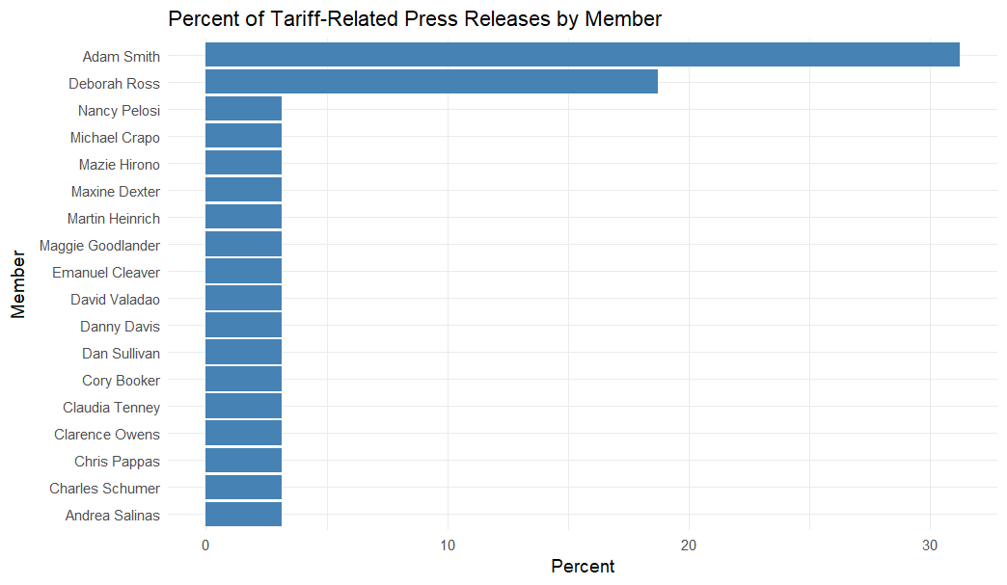

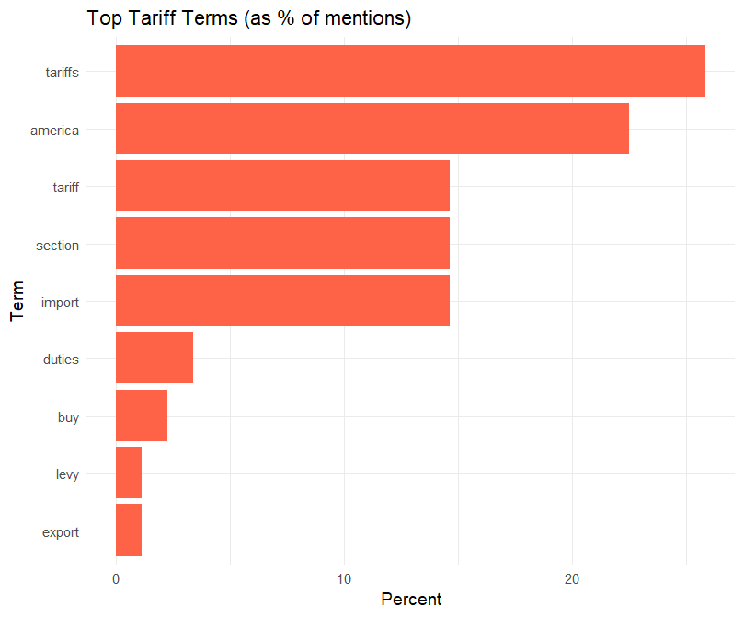

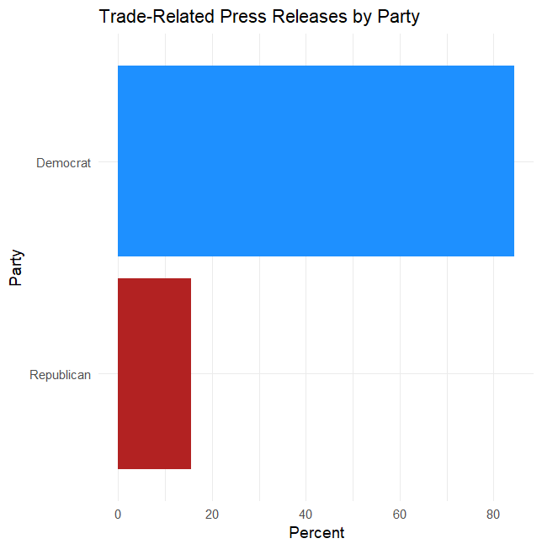

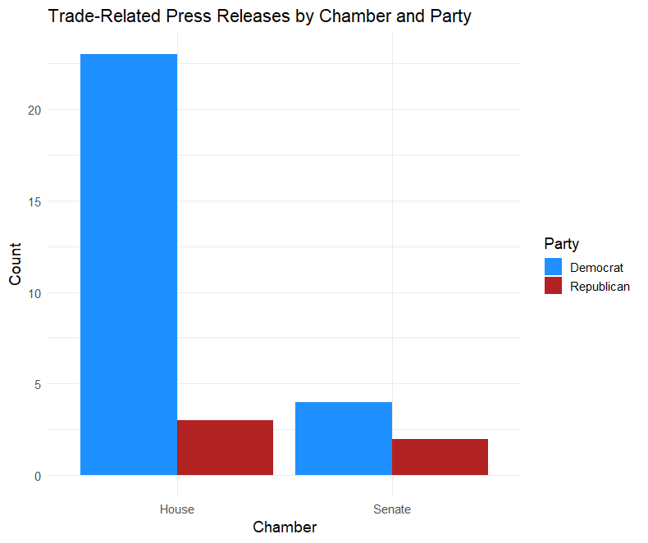

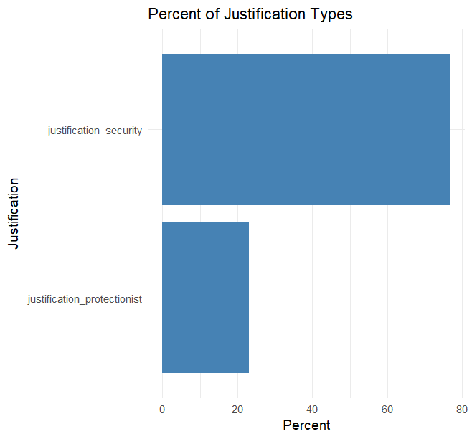

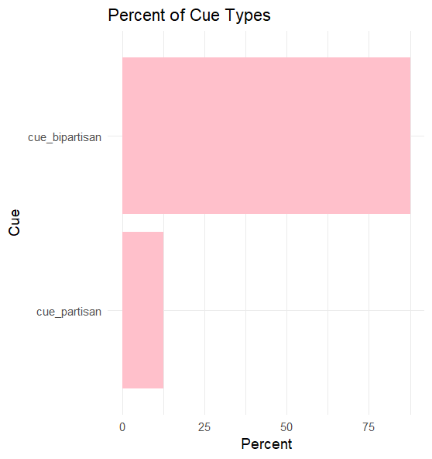

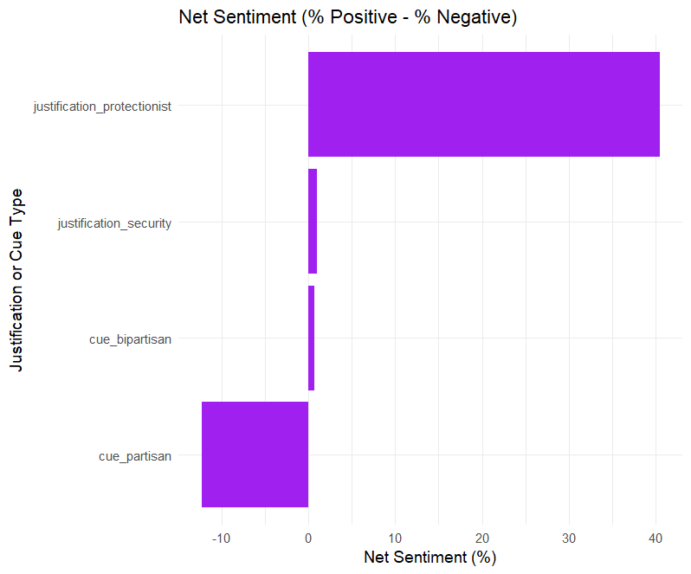

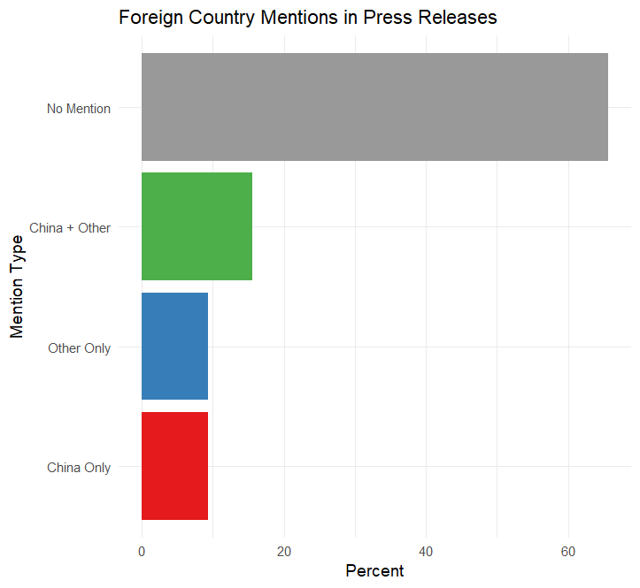

Bibliography

Alt JE, Frieden J, Gilligan MJ, Rodrik D, Rogowski R. 1996. The political economy of international trade: enduring puzzles and an agenda for inquiry. Comp. Political Stud. 29(6):689–717 Baker, Andy. “Who Wants to Globalize? Consumer Tastes and Labor Markets in a Theory of Trade Policy Beliefs.” American Journal of Political Science, vol. 49, no. 4, Oct. 2005, pp. 924–38. DOI.org (Crossref), https://doi.org/10.1111/j.1540-5907.2005.00164.x.

Betz, Timm, and Amy Pond. “The Absence of Consumer Interests in Trade Policy.” The Journal of Politics, vol. 81, no. 2, Apr. 2019, pp. 585–600. DOI.org (Crossref),

https://doi.org/10.1086/701493.

Beaulieu, Eugene. “Factor or Industry Cleavages in Trade Policy? An Empirical Analysis of the Stolper–Samuelson Theorem.” Economics & Politics, vol. 14, no. 2, July 2002, pp. 99–131. DOI.org (Crossref), https://doi.org/10.1111/1468-0343.00102.

Botelho, Anabela, et al. “Testing Static Game Theory with Dynamic Experiments: A Case Study of Public Goods.” Games and Economic Behavior, vol. 67, no. 1, Sept. 2009, pp. 253-265.e3. ScienceDirect, https://doi.org/10.1016/j.geb.2008.11.013.

Blendon, Robert J., et al. “Public Opinion and Trump’s Jobs and Trade Policies.” *Challenge*, vol. 60, no. 3, May 2017, pp. 228–44. *DOI.org (Crossref)*, https://doi.org/10.1080/05775132.2017.1308763. Bloomberg. “House Prepares to Drop China Investment Curbs From Defense Bill.” Bloomberg.Com, 29 Nov. 2023. www.bloomberg.com,

https://www.bloomberg.com/news/articles/2023-11-29/house-prepares-to-drop-china-investment curbs-from-defense-bill.

Boak. “Joe Biden’s ‘Buy America’ Policy on Infrastructure Projects Leads to Factory Jobs in Wisconsin.” AP News, 4 Aug. 2023,

https://apnews.com/article/biden-harris-internet-raimondo-factory-jobs-546af3d3bd9520b1e055d d323e8baf47.

Bogdanova, Iryna. "The WTO Panel Ruling on the National Security Exception: Has the Panel ‘Cut’the Baby in Half?." EJIL: Talk 12 (2019).

Bruetschy, Chantal. “The EU Regulatory Framework on Genetically Modified Organisms (GMOs).” Transgenic Research, vol. 28, no. 2, Aug. 2019, pp. 169–74. Springer Link,

https://doi.org/10.1007/s11248-019-00149-y.

Brutger, Ryan, and Alexandra Guisinger. “Labor Market Volatility, Gender, and Trade Preferences.” Journal of Experimental Political Science, vol. 9, no. 2, July 2022, pp. 189–202. Cambridge University Press, https://doi.org/10.1017/XPS.2021.9.

Bureau of Industry and Security. US Department and Commerce. Section 232 Investigations. https://www.bis.doc.gov/index.php/other-areas/office-of-technology-evaluation-ote/section-232-i nvestigations. Accessed 6 Dec. 2023.

Cohen, Harlen Nations and Markets, Journal of International Economic Law, Volume 23, Issue 4, December 2020, Pages 793–815, https://doi.org/10.1093/jiel/jgaa032

Dadush, Uri. “Industrial Policy: A Guide for the Perplexed.” Carnegie Endowment for International Peace,

https://carnegieendowment.org/2016/02/01/industrial-policy-guide-for-perplexed-pub-62660. Accessed 8 Dec. 2023

Dent, Christopher M. “Brexit, Trump and Trade: Back to a Late 19th Century Future?” Competition & Change, vol. 24, no. 3–4, July 2020, pp. 338–57. DOI.org (Crossref),

https://doi.org/10.1177/1024529420921481.

Essig, Joseph, et al. “The ‘Trump’ Effect: Political Elite and Support for Free Trade in America.” American Politics Research, vol. 49, no. 3, May 2021, pp. 328–42. DOI.org (Crossref), https://doi.org/10.1177/1532673X21992124.

Gillespie, Patrick. “Obama Got Tough on China. It Cost U.S. Jobs and Raised Prices.” CNNMoney, 3 Jan. 2017, https://money.cnn.com/2017/01/03/news/economy/obama-china-tire-tariff/index.html. Guisinger, Alexandra. “Determining Trade Policy: Do Voters Hold Politicians Accountable?” International Organization, vol. 63, no. 3, July 2009, pp. 533–57. Cambridge University Press, https://doi.org/10.1017/S0020818309090183.

Feenstra RC. 2015. Advanced International Trade: Theory and Evidence. Princeton, NJ: Princeton Univ. Press

Hiscox MJ. 2002. Commerce, coalitions, and factor mobility: evidence from congressional votes on trade legislation. Am. Political Sci. Rev. 96(3):593–608

Kertzer, Joshua D., and Ryan Brutger. “Decomposing Audience Costs: Bringing the Audience Back into Audience Cost Theory.” American Journal of Political Science, vol. 60, no. 1, Jan. 2016, pp. 234–49. DOI.org (Crossref), https://doi.org/10.1111/ajps.12201.

Keser, Ceren, et al. “Partisanship, Trump Favorability, and Changes in Support for Trade.” Presidential Studies Quarterly, Oct. 2023, p. psq.12861. DOI.org (Crossref),

https://doi.org/10.1111/psq.12861.

Kono, Daniel Y. 2006. “Optimal Obfuscation: Democracy and Trade PolicyTransparency.” American PoliticalScienceReview 10(3): 369-384.

Kono, Daniel Y. “Does Public Opinion Affect Trade Policy?” Business and Politics, vol. 10, no. 2, Aug. 2008, pp. 1–19. Cambridge University Press, https://doi.org/10.2202/1469-3569.1224. Kim IS. 2017. Political cleavages within industry: firm-level lobbying for trade liberalization. Am. Political Sci. Rev. 111(1):1–20

Krugman P. 1980. Scale economies, product differentiation, and the pattern of trade.Am. Econ. Rev. 70(5):950–59

List; Friend or Foe? A Natural Experiment of the Prisoner's Dilemma. The Review of Economics and Statistics 2006; 88 (3): 463–471. doi

Mayhew, David R. Congress: The Electoral Connection. Second edition, Yale University Press, 2004. Mutz, Diana C., and Eunji Kim. “The Impact of In-Group Favoritism on Trade Preferences.” International Organization, vol. 71, no. 4, Oct. 2017, pp. 827–50. Cambridge University Press, https://doi.org/10.1017/S0020818317000327.

Osgood I. 2017. The breakdown of industrial opposition to trade: firms, product variety, and reciprocal liberalization. World Politics 69(1):184–231

Potter, Philip B. K., and Matthew A. Baum. “Democratic Peace, Domestic Audience Costs, and Political Communication.” Political Communication, vol. 27, no. 4, Oct. 2010, pp. 453–70. DOI.org (Crossref), https://doi.org/10.1080/10584609.2010.516802.

Rapoza, Kenneth. “Obama’s Half-Truth On China Tire Tariffs.” Forbes,

https://www.forbes.com/sites/kenrapoza/2012/01/25/obamas-half-truth-on-china-tire-tariffs/. Accessed 5 Dec. 2023.

Rogers, Everett M., and James W. Dearing. “Agenda-Setting Research: Where Has It Been, Where Is It Going?” Communication Yearbook 11, Routledge, 1988.

Scruby, Sam. What We Talk About When We Talk About NAFTA: Elite Discourse, Public Opinion, and the North American Free Trade Agreement. University of Chicago

Siripurapu Anshu and Noah Berman. “Is Industrial Policy Making a Comeback?” Council on Foreign Relations, https://www.cfr.org/backgrounder/industrial-policy-making-comeback. Accessed 5 Dec. 2023.

Tankersley, Jim. “Trump’s Washing Machine Tariffs Stung Consumers While Lifting Corporate Profits.” The New York Times, 21 Apr. 2019. NYTimes.com,

https://www.nytimes.com/2019/04/21/business/trump-tariffs-washing-machines.html. Tomz, Michael. “Domestic Audience Costs in International Relations: An Experimental Approach.” International Organization, vol. 61, no. 4, Oct. 2007, pp. 821–40. Cambridge University Press, https://doi.org/10.1017/S0020818307070282.

Velo, Jakob “EU Readies Response to Biden’s ‘Buy American’ Pitch.” POLITICO, 4 May 2021, https://www.politico.eu/article/eu-response-joe-biden-buy-american-us/.

Wade, Robert H. “Return of Industrial Policy?” Economic Policies of the New Thinking in Economics, Routledge, 2013.

Warwick, Ken. Beyond Industrial Policy: Emerging Issues and New Trends. OECD, 5 Apr. 2013. OECD iLibrary, https://doi.org/10.1787/5k4869clw0xp-en.

Wessel, Ramses A., and Ige F. Dekker. “Identities of States in International Organizations.” International Organizations Law Review, vol. 12, no. 2, Apr. 2015, pp. 293–318. brill.com,

https://doi.org/10.1163/15723747-01202002.

Young, Oran R. “Political Leadership and Regime Formation: On the Development of Institutions in International Society.” International Organization, vol. 45, no. 3, July 1991, pp. 281–308. Cambridge University Press, <https://doi.org/10.1017/S0020818300033117>.

Methodological Appendix

Table of Contents

1. Coefficient Plots

2. Kernel Density Model

- Model Selection Rationale

- Model Description

- Derivation of the Model

- Assumptions and Testing

3. Ordinal Logit Model

- Model Selection Rationale

- Model Description

- Derivation of the Model

- Assumptions and Testing

4. Logit Model

- Model Selection Rationale

- Model Description

- Derivation of the Model

- Assumptions and Testing

5. Ordinal Logit Model Table of Results

6. Logit Model Table of Results

Coefficient Plots

Vote Outcome by Party

2. Kernel Density Model

Model Selection Rationale

The Nonparametric Maximum Likelihood Estimation (Kernel Density Estimation) was chosen to analyze the dependent variable, Support for Tariff Policies, which is continuous and expected to exhibit skewness (left-skewed). The model’s flexibility allows for estimating the probability density function without assuming a parametric distribution, making it suitable for uncovering the true underlying distribution.

Model Description

Kernel Density Estimation (KDE) smooths the observed data using a kernel function $(K\left(⋅\right))$ and a bandwidth parameter $( h ).$ The density at a point $( x )$ is estimated as:

$$\hat{f}\left(x\right)=\frac{1}{nh}\sum_{i=1}^{n}{K\left(\frac{x-x_{i}}{h}\right)},$$

where:

- Sample size,

- Observed data points,

- Bandwidth controlling the level of smoothness.

Common choices for the kernel include Gaussian, Epanechnikov, and Uniform. I choose Gaussian because that what most of the filed uses.

Derivation of the Model

The likelihood function for kernel density estimation is constructed by considering the product of densities at each observed point:

$$L\left(f\right)=\prod_{i=1}^{n}{f\left(x_{i}\right)}.$$

Substituting the kernel density estimator \( \hat{f}(x_i) \):

$$L\left(\hat{f}\right)=\prod_{i=1}^{n}{\frac{1}{nh}}\sum_{j=1}^{n}{K\left(\frac{x_{i}-x_{j}}{h}\right)}.$$

Maximizing this likelihood function with respect to the bandwidth $h$ ensures optimal smoothing of the density estimate.

Assumptions and Testing

- **Continuity**: KDE assumes the variable of interest is continuous.

- **Independence**: Observations must be independent and identically distributed (i.i.d.).

- **Bandwidth Selection**: Appropriate tests (e.g., cross-validation) were conducted to select the optimal bandwidth, ensuring a balance between bias and variance. The null hypothesis that the selected bandwidth minimizes error was rejected.

2. Ordinal Logit Model

Model Selection Rationale

The Ordinal Logit Model was employed to examine a Likert-scale dependent variable, such as Attitudes toward Trade Policies. This model is ideal because the responses are ordinal, and it can handle data with most responses clustered in the middle of the scale.

Model Description

The ordinal logit model assumes a latent variable y* which is linearly related to the predictors x:

y $=β_{0}+βx+ϵ, ϵ∼\text{logistic}\left(0,1\right).$

*

The observed outcome y is determined by thresholds $( mu_{j}),$ with $( J )$ categories:

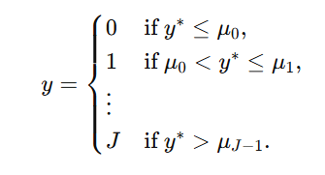

The likelihood function for $( n )$ observations is given by:

$$L\left(β,μ\right)=\prod_{i=1}^{n}{P\left(y_{i} | x_{i}\right)},$$

where:

$$P\left(y_{i} | x_{i}\right)=Λ\left(μ_{j}-βx_{i}\right)-Λ\left(μ_{j-1}-βx_{i}\right),$$

and $(Λ\left(z\right))$ is the cumulative distribution function (CDF) of the logistic distribution:

$$Λ\left(z\right)=\frac{1}{1+\exp\left(-z\right)}.$$

Derivation of the Model

The log-likelihood function is:

$$\ln{L}\left(β,μ\right)=\sum_{i=1}^{n}{i}\ln\left[Λ\left(μ_{j}-βx_{i}\right)-Λ\left(μ_{j-1}-βx_{i}\right)\right].$$

Maximization of the log-likelihood function is performed to estimate the parameters $( β)$ $and ( μ).$

Assumptions and Testing

- **Proportional Odds**: The coefficients across threshold equations are assumed to be constant (parallel regression assumption). This was tested using the Brant test, rejecting the null hypothesis of proportional odds violation.

- **Independence of Errors**: Residuals are assumed to follow a logistic distribution with mean 0 and variance

- **Model Fit**: Likelihood ratio tests and goodness-of-fit metrics indicated the model was appropriate.

3. Logit Model

Model Selection Rationale

The Logit Model was used to analyze Vote Choice as the dependent variable because it is binary. This model provides an interpretable framework for estimating the likelihood of a positive outcome.

Model Description

The binary logit model specifies the probability of a positive outcome $\left(y=1\right)$ as:

$$P\left(y=1 | x\right)=\frac{\exp\left(β_{0}+βx\right)}{1+\exp\left(β_{0}+βx\right)},$$

where $( x )$ includes treatment and control variables. The complementary probability is $(P\left(y=0 | x\right)=1-P\left(y=1 | x\right)).$

The likelihood function for $( n )$ observations is:

$$L\left(β\right)=\prod_{i=1}^{n}{\left[P{\left(y_{i}=1 | x_{i}\right)}^{y_{i}}⋅{\left(1-P\left(y_{i}=1 | x_{i}\right)\right)}^{1-y_{i}}\right]}.$$

Derivation of the Model

The log-likelihood function is:

$$\ln{L}\left(β\right)=\sum_{i=1}^{n}{\left[y_{i}\ln{P}\left(y_{i}=1 | x_{i}\right)+\left(1-y_{i}\right)\ln\left(1-P\left(y_{i}=1 | x_{i}\right)\right)\right]}.$$

Substituting the probability function:

$$\ln{L}\left(β\right)=\sum_{i=1}^{n}{\left[y_{i}\left(β_{0}+βx_{i}\right)-\ln\left(1+\exp\left(β_{0}+βx_{i}\right)\right)\right]}.$$

Maximization of the log-likelihood function yields estimates for the parameter vector \( \beta \).

Assumptions and Testing

- **Binary Nature**: The dependent variable must be binary (0 or 1).

- **Independence of Observations**: Assumes i.i.d. data points.

- **Model Fit**: Likelihood ratio and Wald tests confirmed the significance of predictors. The null hypothesis of no effect was rejected.

- **Linearity in Log-Odds**: Assumes predictors have a linear relationship with the log-odds.

4. Kernel Density Model Table of Results

4. Ordinal Logit Model of Results

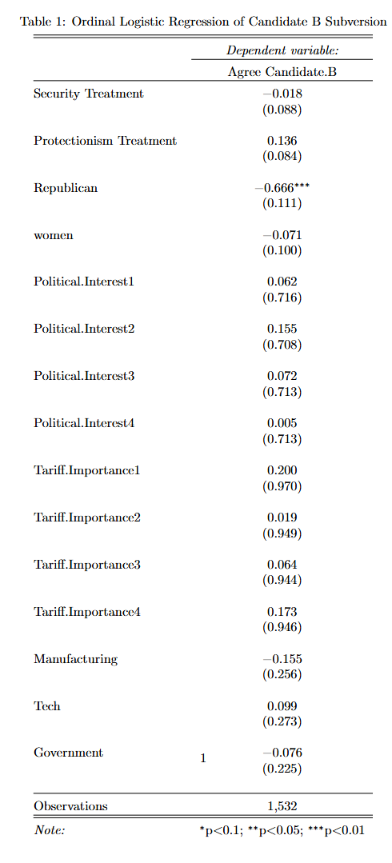

5. Logit Model of Results

